Digital Competence

Discussion Forum Suggestions

Discussion Forums

There are a number of discussion forums in each course. These are currently empty. As a facilitator, you can add the topics you wish here. We have listed suggested topics for each forum.

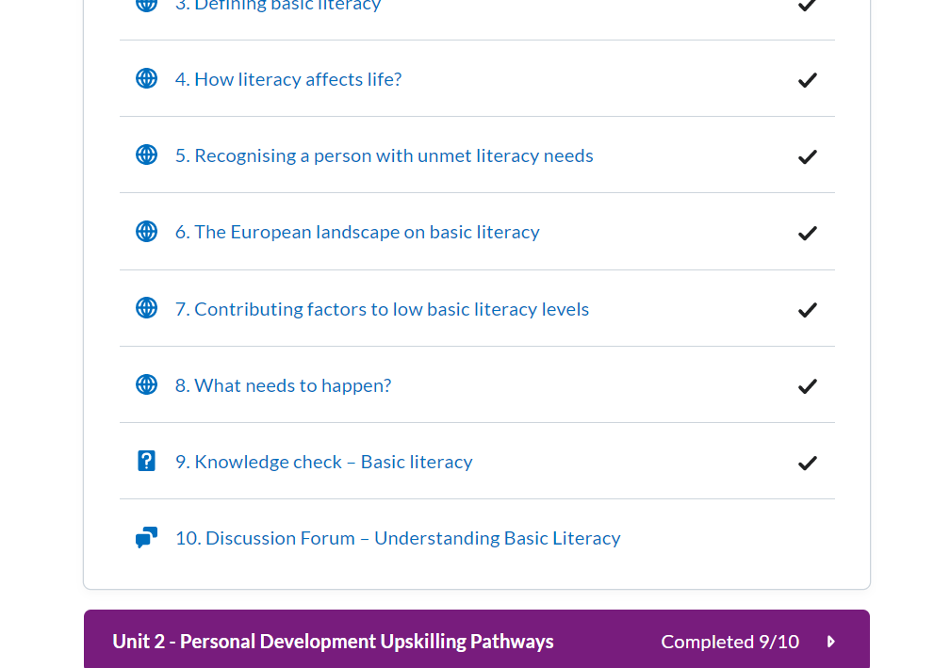

# How to use discussion forums

Click on the Discussion topic and **start a new thread** to edit

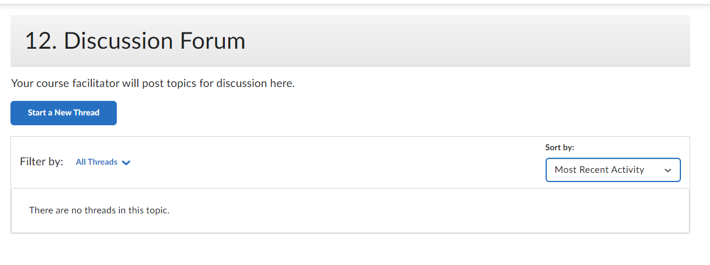

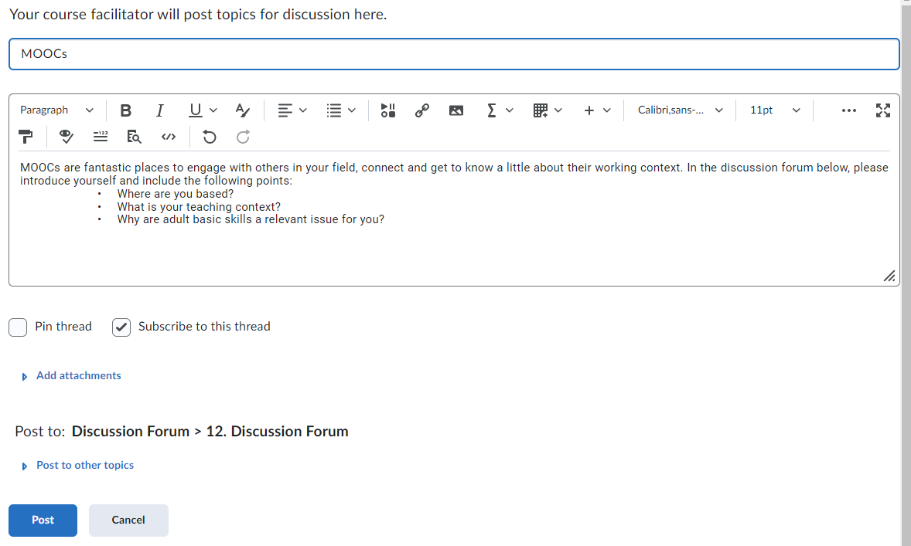

Click **‘post’** to create the topic

# Badges:

Learners will get a Digital badge if they post in each discussion forum. They can either reply to a thread or start their own thread.

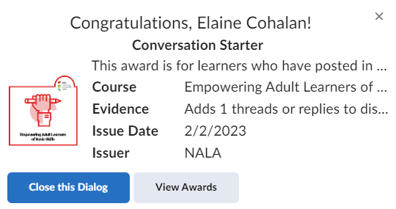

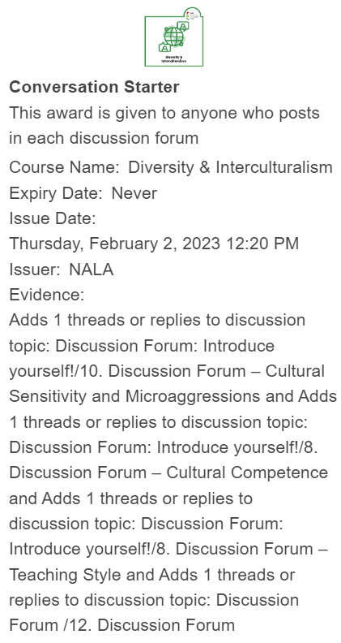

# Possible Issues with Discussion Forums:

As mentioned it above. It is suggested that you only edit the Discussion Forums through the “Content” button and not through Discussions  on the Navbar.

### Hidden Discussion Forums

Discussion forums can be hidden by going to “Discussions” in the Navbar. It is not recommended that you do this. If the Discussion forum isn’t visible it will say “hidden” beneath it. You can make it visible by selecting “Make visible to users”.



Unit 1:

*11. Discussion Forum*

Topics suggested for discussion:

In the discussion forum we would like you to post about how you would plan lessons where digital skills is the subject using these following pointers:

* How would plan and facilitate a lesson for a group of participants who will use digital tools to create CVs.
* How can you in this lesson influence and motivate participants to use digital tools for similar tasks

*Please also ensure you comment on at least 2 of your peers’ submissions*

Unit 2:

*9. Discussion forum*

Topics suggested for discussion:



Some learners are maybe “false beginners” i.e. they know the most basic things, while others are “real” beginners. The same progression can be experienced as frightening, adequate or boring, because the learners are so different.

**How/is it possible to organize the group and learning activities in a way that includes diversity both in regards of progress and a content that is relevant for the learners?**

Or

While ICT classes used to be computer based, many of our learners may not have a computer, but uses Padlet or smartphones as their digital tools.

**How / is it possible to deal with a class where the learners have mixed tools? Which limitations (if any)**

Unit 3:

*10.* *Discussion Forum – Digital Skills for Work Life*



* What do you think are the biggest differences in teaching basic digital skills at work-related courses compared to “standard” courses?
* If you already have taught these kind of courses: What was your involvement in the planning and preparation of courses for the workplace?

Unit 4:

# 10. Discussion Forum – Common Concerns for Facilitators



Topics suggested for discussion:

Teaching basic digital skills online may seem like an oxymoron, but it actually happens.

* Have you any experience with that? What prerequisites do you believe should be present for the participants to succeed?
* Does online teaching promote specific learning styles and /or teaching styles?